

**Course code 206**

**Course Name   
Software engineering Theory**

Phase 2: Software Design Document Team Name :

MMA TEAM

# 26 Dec 2020

**Contents**

Team 3

Document Purpose and Audience 3

System Models 4

1. Class diagrams 4
2. Sequence diagrams 5

Class - Sequence Usage Table 11

1. Physical Entity-Relationship Diagram 12
2. User Interface Design 8
3. Algorithms and Data Structures 19

Ownership Report 26

Policy Regarding Plagiarism 26

## Team

|  |  |  |  |
| --- | --- | --- | --- |
| **ID** | **Name** | **Email** | **Mobile** |
| 203141 | Mostafa Ashraf | [sim.mostafaashraf3141@alexu.edu.eg](mailto:sim.mostafaashraf3141@alexu.edu.eg) | 01008365961 |
| 203110 | Mohamed Ahmed Ibrahim | sim.mohamedahmed3110@alexu.edu.eg | 01097221067 |
| **203018** | Adham Mohamed |  | 01201373232 |

## Document Purpose and Audience

## Software Purpose

* **To Automate Gym & Fitness admission Process.**

## Software Scope

* **selecting a trainer is difficult. Sometimes it is difficult to get a desired slot timing**
* **Being healthy is the first thing to be kept in mind because most of the time our attitude depends on how we feel**

**List of the Target Audience :**

1. Developers

2. Programmers

3. Business professionals

4. Stakeholders

## System Models

### Class diagrams

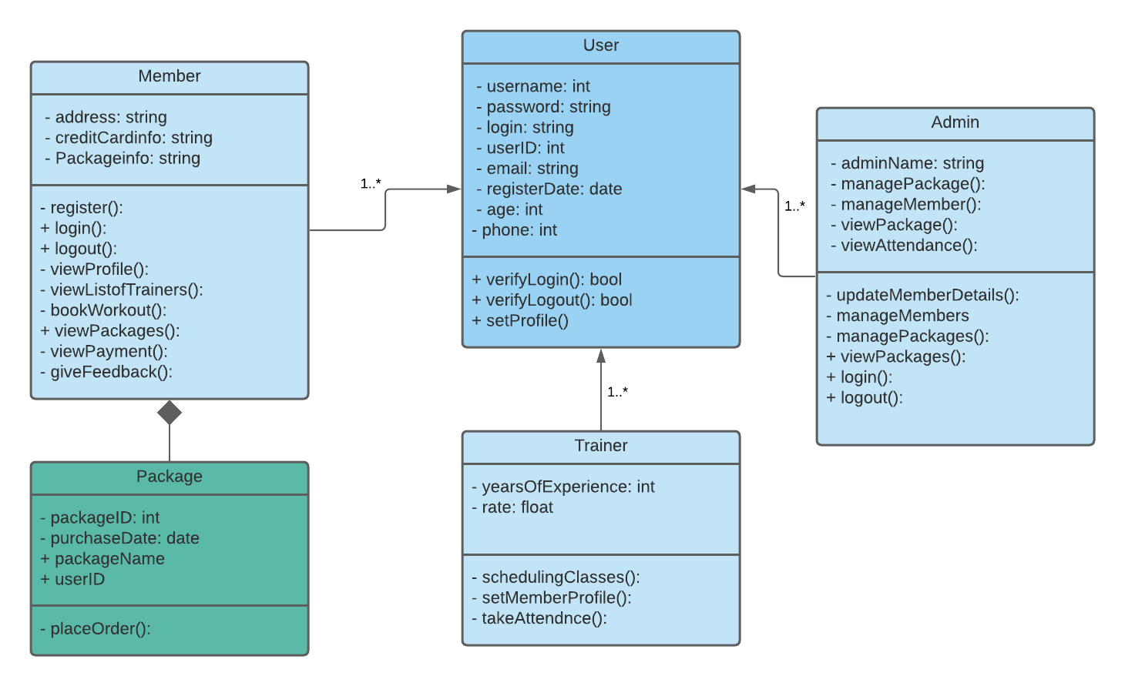

|  |  |  |  |
| --- | --- | --- | --- |
| **Class ID** | **Class Name** | **Subsystem ID** | **Description & Responsibility** |
| 001 | User | None | Set up profile and take the data of the user |
| 002 | Member | 6.7 | View list of trainers and Enroll in chosen package |
| 003 | Admin | 3 | Manage the system |
| 004 | Trainer | None | Take attendance and years of experiences |
| 005 | Package | 7 | Placing order and save purchase date |

### Sequence diagrams

**1.Login :**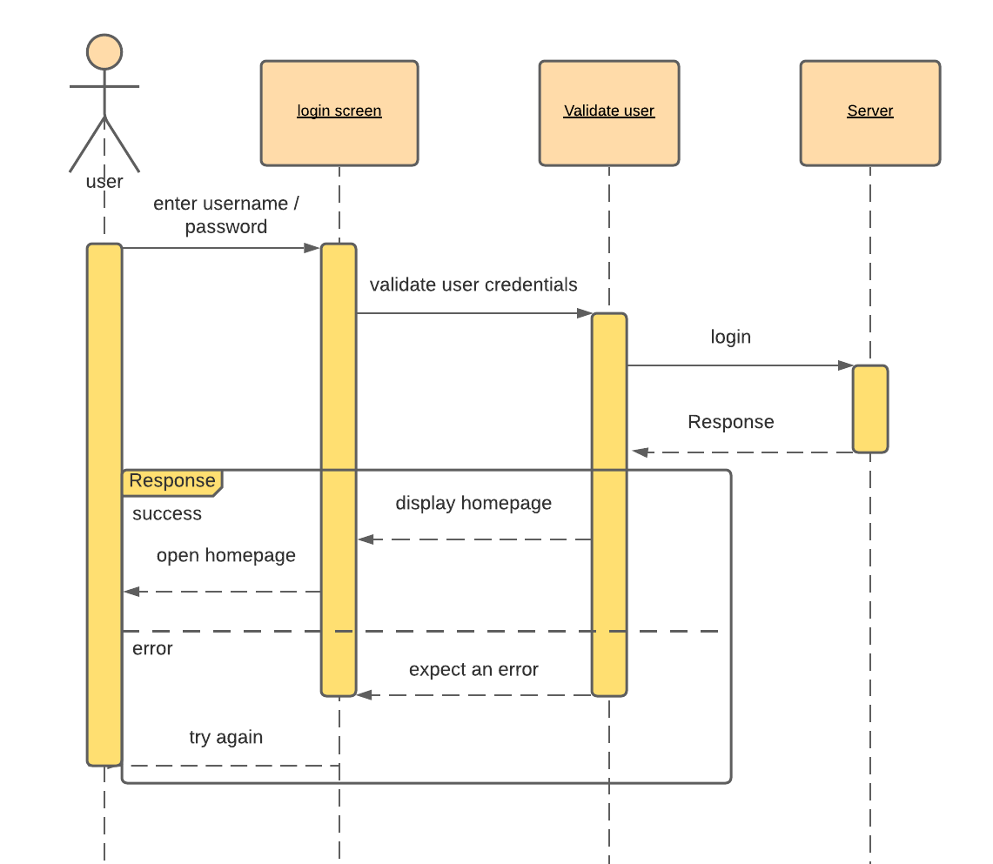

**2.register:**

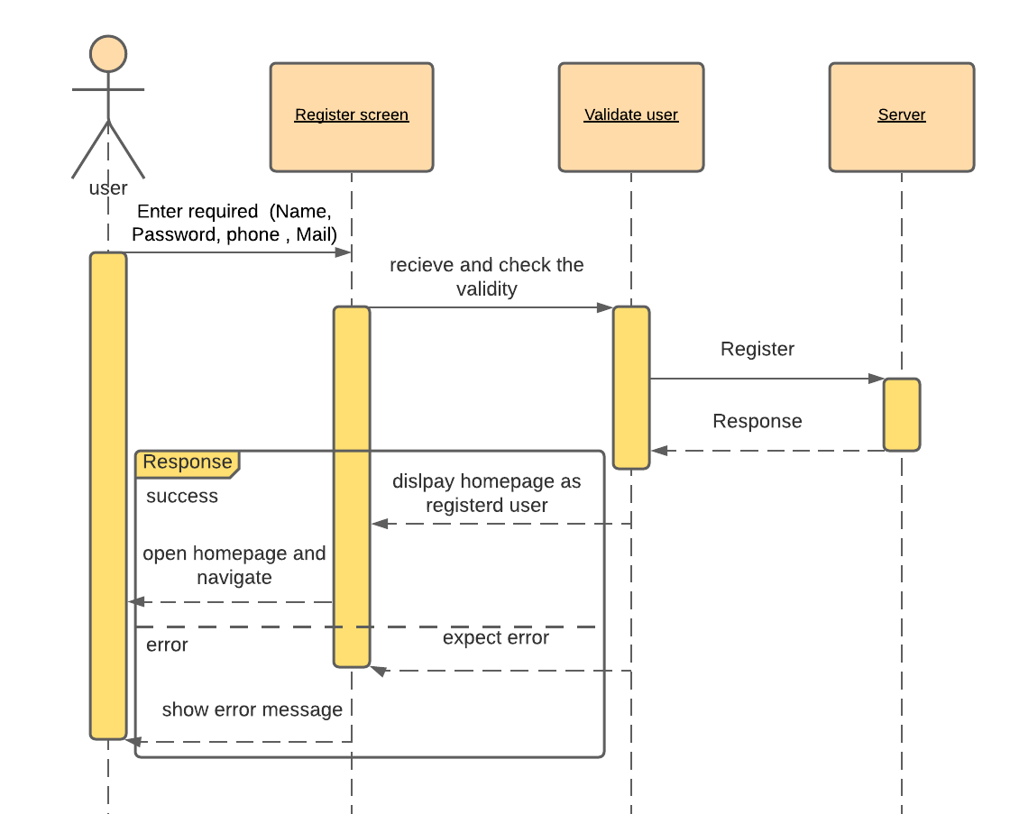

**3.** **change password:**

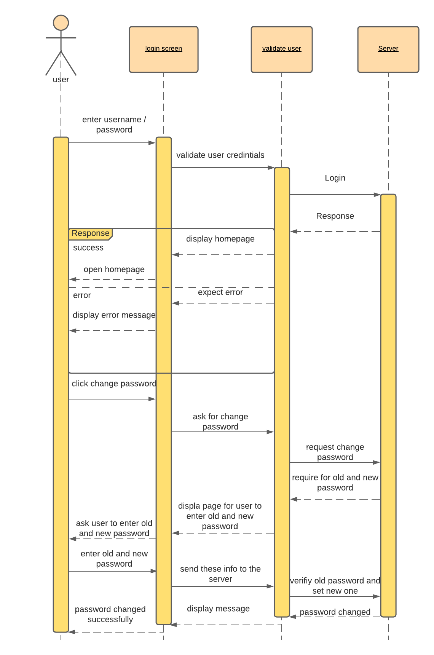

**4.** **book workout:**

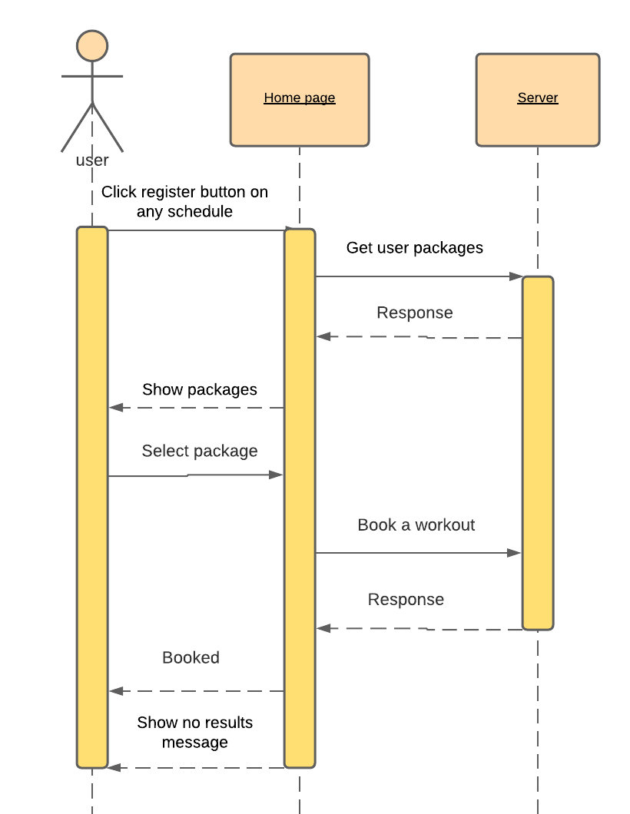

**5.view list of trainers:**

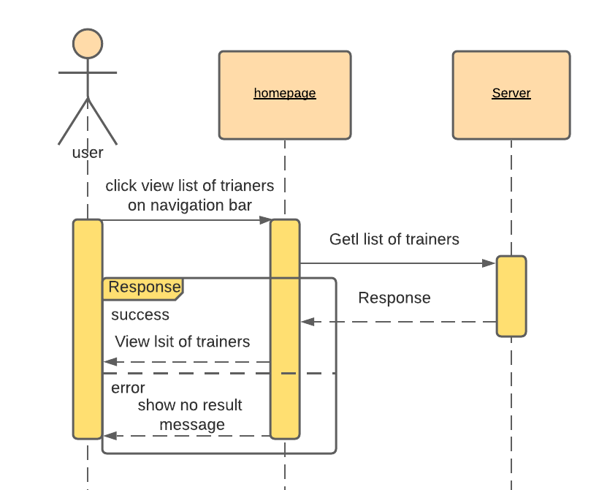

**6.** **view packages:**

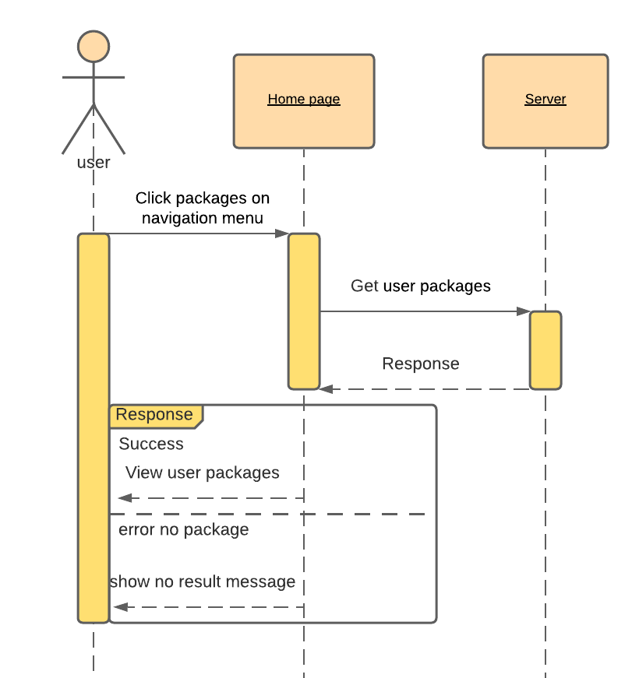

Class - Sequence Usage Table

|  |  |  |
| --- | --- | --- |
| **Class Name** | **Sequence Diagrams** | **Overall used methods** |
| User | 1 | Verifylogin() |
| Admin | 2 | Verifylogin() , Managepackage() |
| Admin | 3 | Verifylogin() , ManagememberDetails() ,ViewAttendance() |
| Member | 4 | Verifylogin() , Viewprofile() , Setprofile() |
| Member | 5 | Verifylogin() , GiveFeedback() |
| Trainer | 6 | Verifylogin() , TakeAttendance() |

### Physical Entity-Relationship Diagram

### User Interface Design

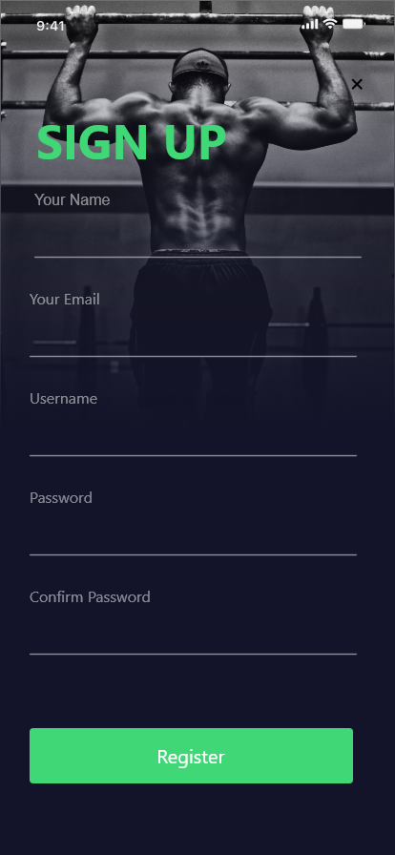

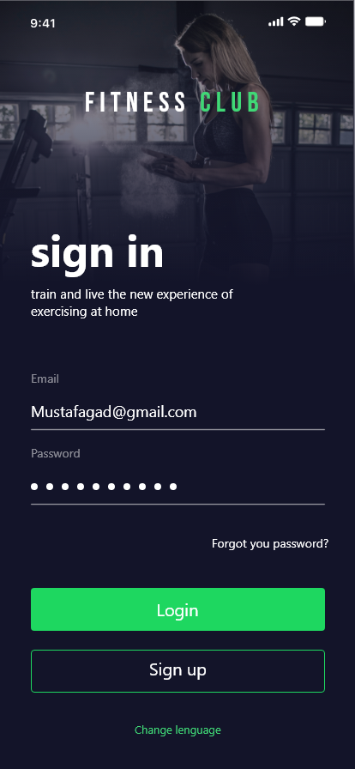



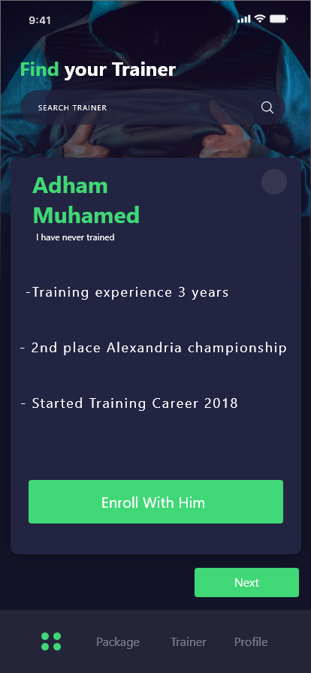

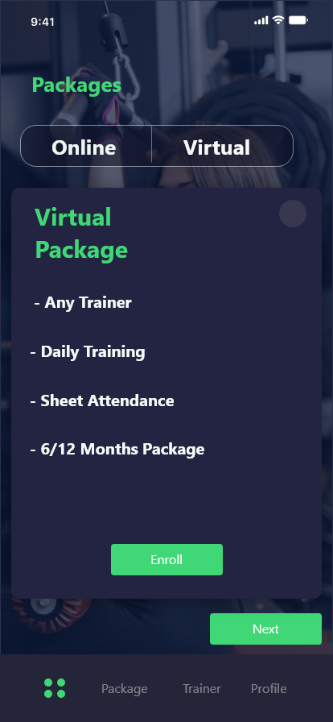

### Dataflow diagram (DFD)

**Zero level diagram:**

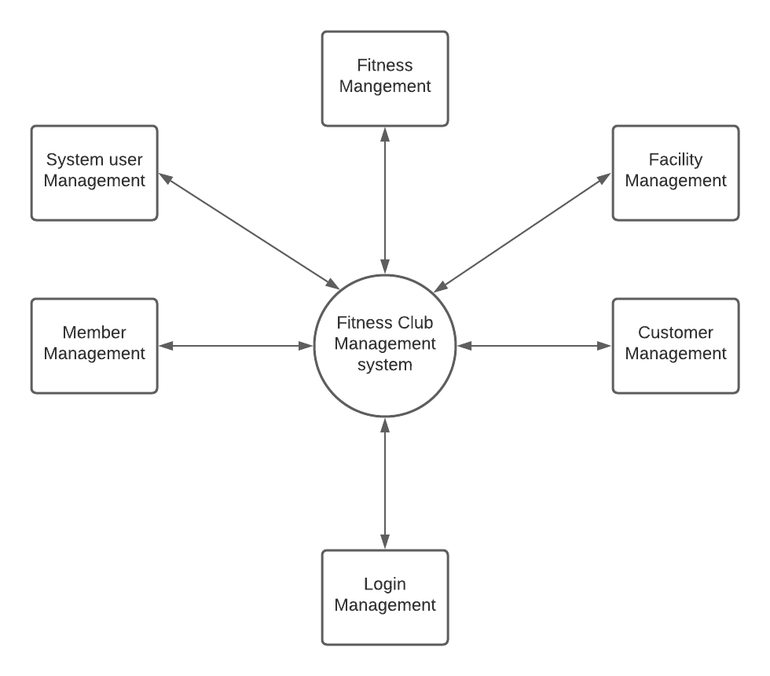

**One level diagram :** 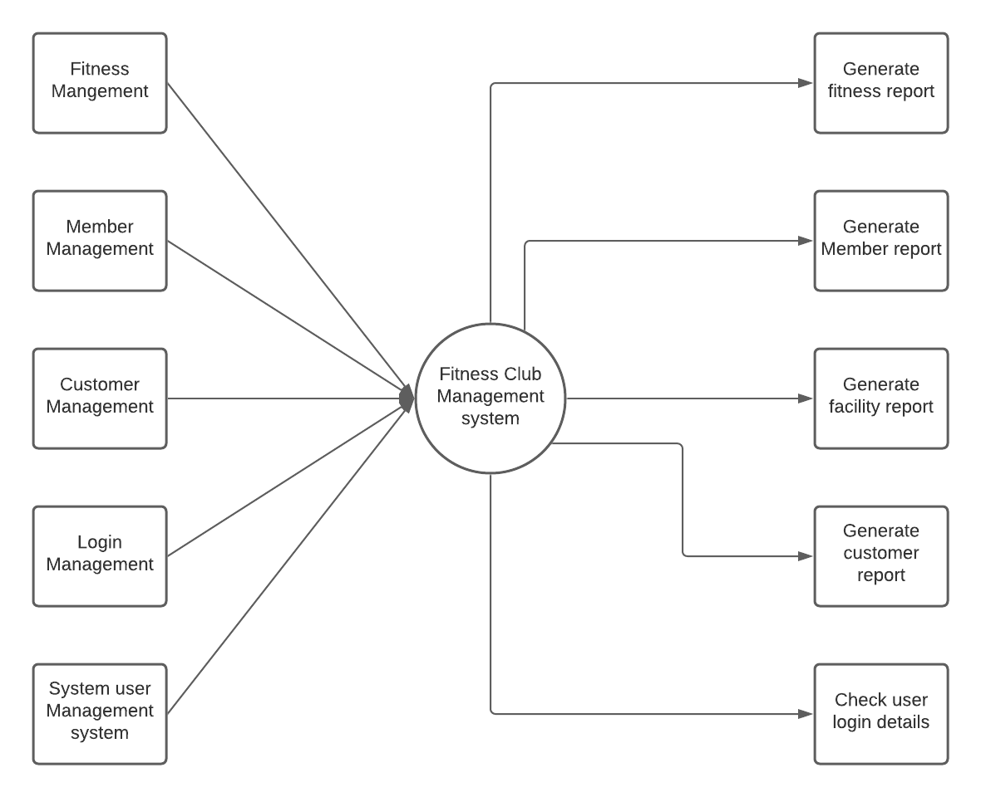

**Two level diagram :**

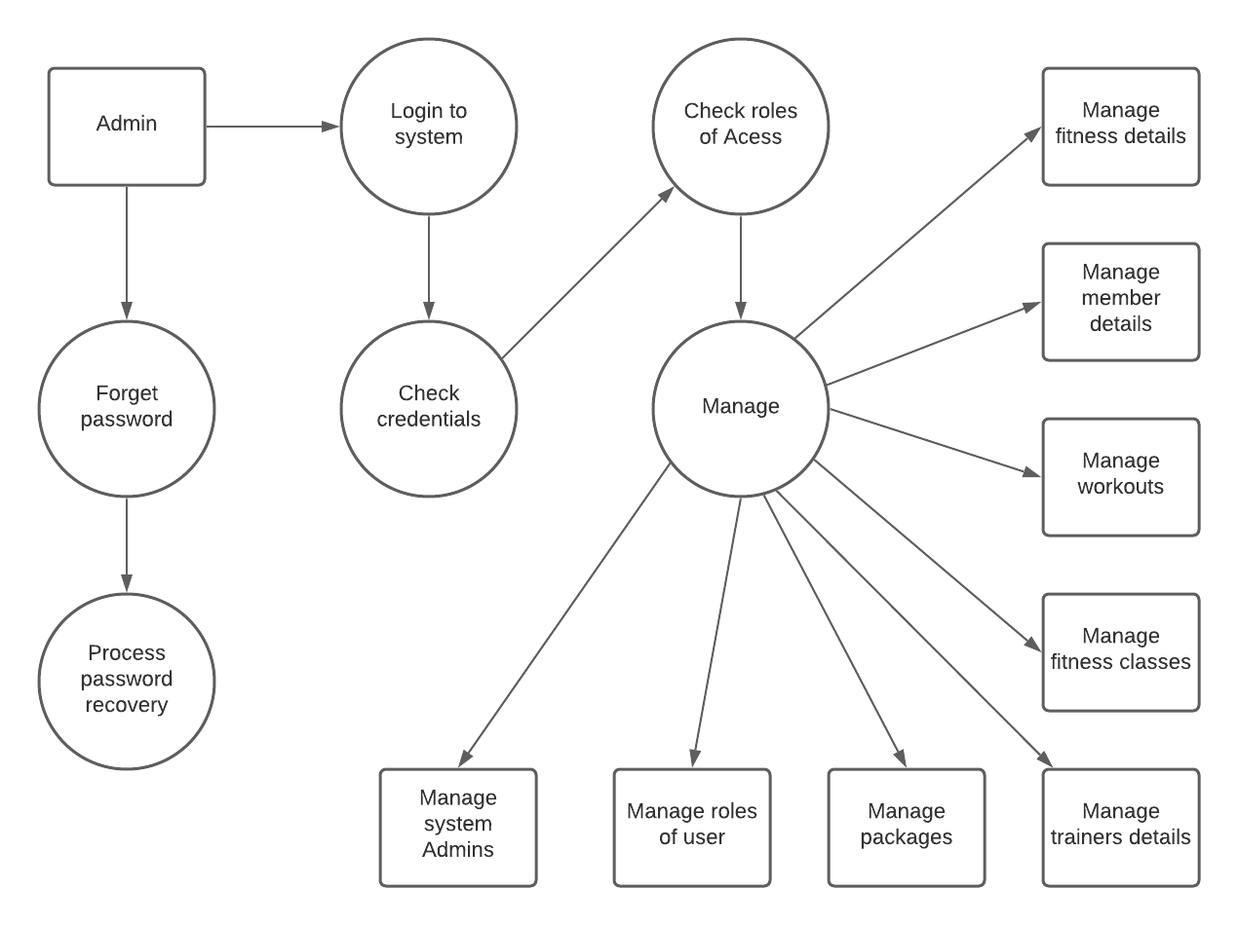

### Algorithms and Data Structures

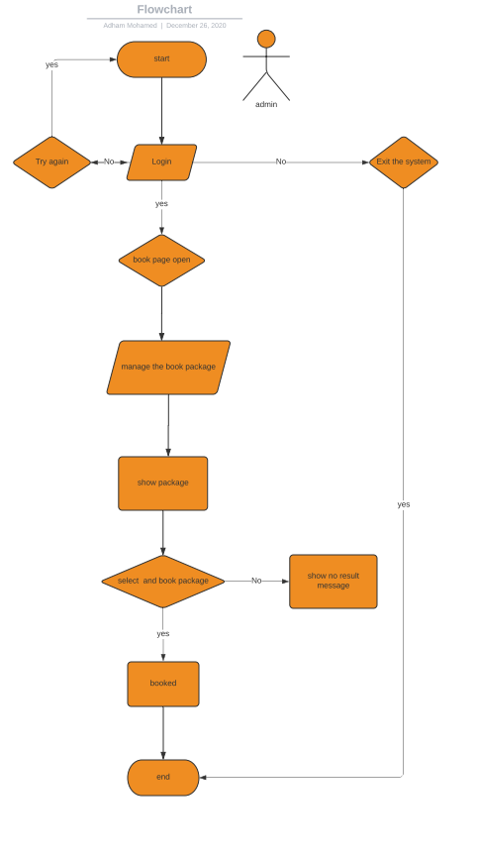

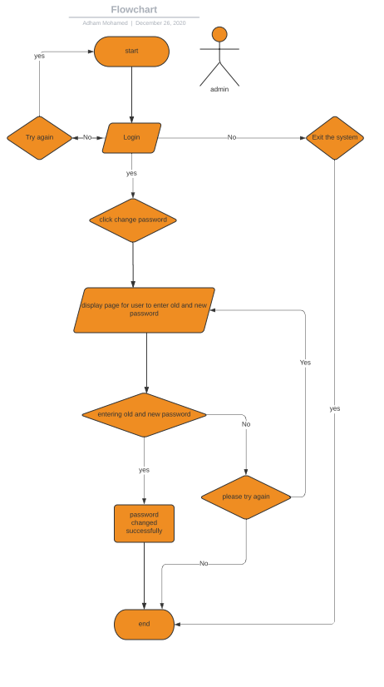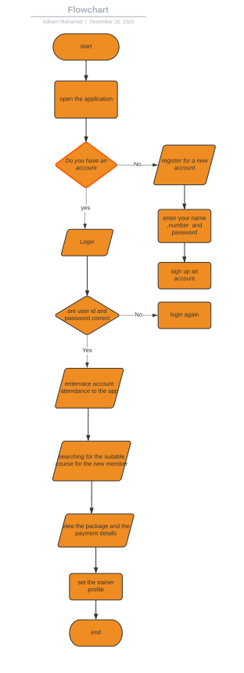

## Ownership Report

|  |  |
| --- | --- |
| **Item** | **Owners** |
| None |  |
| None |  |

Policy Regarding Plagiarism**:**

**Students have collective ownership and responsibility of their project. Any violation of academic honesty will have severe consequences and punishment for ALL team members.**

.